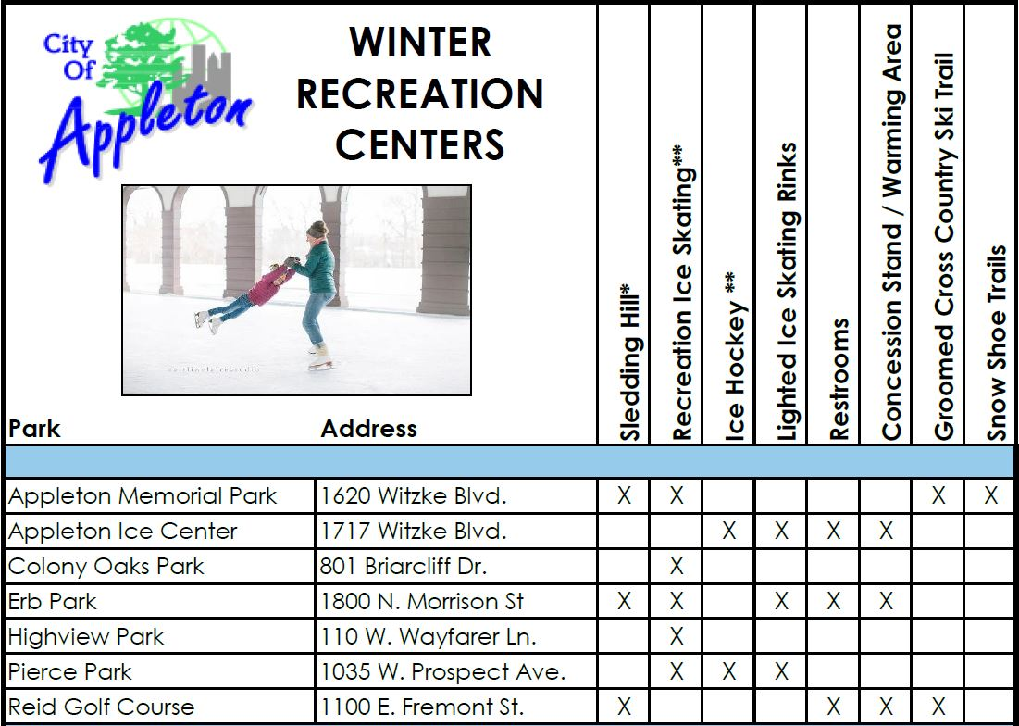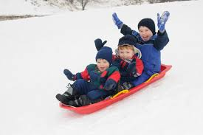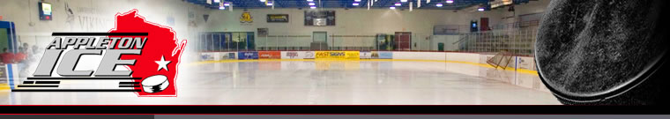

**Warming Facilities & Concession Hours of Operations:**

**Reid Golf Course:** Saturday & Sunday 12:00 p.m. - 6:00 p.m.

**Erb Park:** Monday – Friday 5:00 - 8:00 p.m.   
Saturday & Sunday 12:00 p.m. - 6:00 p.m.

**NOTE:** Warming Facilities may close early due to lack of attendance or weather conditions

CHECK OUT OUR EXTENDED HOURS FOR WINTER BREAK   
AND NO SCHOOL DAYS!

**APPLETON FAMILY ICE CENTER**

The Appleton Family Ice Center offers a variety of learn to skate opportunities, open skating, hockey camps and clinics and more! [www.appletonice.org](http://www.appletonice.org)

***2018 and/or 2019 Park & Rec Annual swim pass holders get $3 admission and $2 skate rentals!***

**Winter Recreation Centers are open normal park hours of 5:00 a.m. to 11:00 p.m.**\*Do not make jumps on any sledding hills and obey all rule signs posted.**Hockey only allowed on designated hockey rinks

**WINTER RECREATION**

Take advantage of the great outdoors and the numerous winter recreational opportunities we have to offer right in your backyard! Spend an afternoon or evening with your family at one of our winter recreation centers throughout the city that include various activities such as sledding, ice skating and cross country skiing. We are happy to provide warming facilities at Erb Park and Reid Golf Course from **Saturday, December 22 through Sunday, February 17**. These facilities will be supervised warming areas with restrooms and a variety of concessions.

***Get out, get active, get involved!***